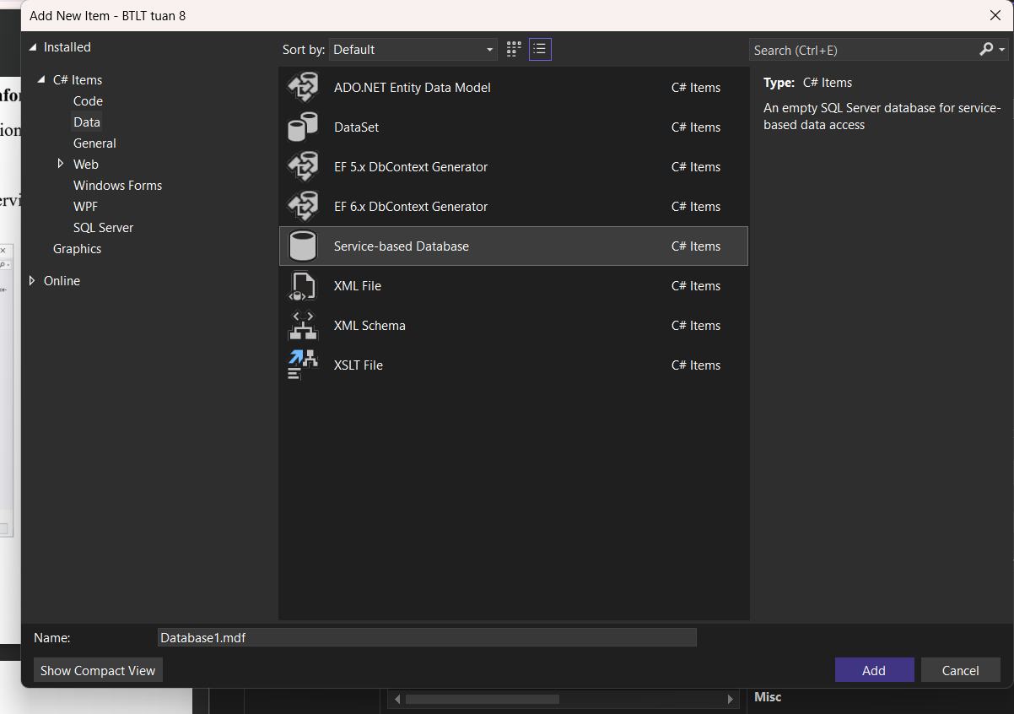

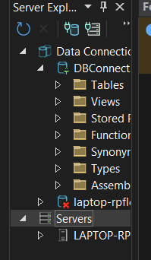

Thực hành 2

using System;

using System.Data;

using System.Data.SqlClient;

using System.Windows.Forms;

namespace Lab5_QuanLySinhVien_KhongParameter

{

public partial class Form1 : Form

{

// Chuỗi kết nối CSDL (.mdf)

string strCon = @"Data Source=(LocalDB)\MSSQLLocalDB;

AttachDbFilename=|DataDirectory|\QuanLySinhVien.mdf;

Integrated Security=True";

SqlConnection sqlCon = null;

public Form1()

{

InitializeComponent();

}

// Mở kết nối

private void MoKetNoi()

{

if (sqlCon == null)

sqlCon = new SqlConnection(strCon);

if (sqlCon.State == ConnectionState.Closed)

sqlCon.Open();

}

// Đóng kết nối

private void DongKetNoi()

{

if (sqlCon != null && sqlCon.State == ConnectionState.Open)

sqlCon.Close();

}

// Hiển thị danh sách sinh viên

private void HienThiDanhSach()

{

MoKetNoi();

SqlCommand cmd = new SqlCommand("SELECT * FROM SinhVien", sqlCon);

SqlDataReader reader = cmd.ExecuteReader();

lsvDanhSach.Items.Clear();

while (reader.Read())

{

string maSV = reader.GetString(0);

string tenSV = reader.GetString(1);

string gioiTinh = reader.GetString(2);

string ngaySinh = reader.GetDateTime(3).ToString("dd/MM/yyyy");

string queQuan = reader.GetString(4);

string maLop = reader.GetString(5);

ListViewItem item = new ListViewItem(maSV);

item.SubItems.Add(tenSV);

item.SubItems.Add(gioiTinh);

item.SubItems.Add(ngaySinh);

item.SubItems.Add(queQuan);

item.SubItems.Add(maLop);

lsvDanhSach.Items.Add(item);

}

reader.Close();

DongKetNoi();

}

// Nút Thêm sinh viên (KHÔNG dùng Parameter)

private void btnThem_Click(object sender, EventArgs e)

{

MoKetNoi();

try

{

string maSV = txtMaSV.Text.Trim();

string tenSV = txtTenSV.Text.Trim();

string gioiTinh = cbGioiTinh.Text.Trim();

string ngaySinh = dtpNgaySinh.Value.ToString("yyyy/MM/dd");

string queQuan = txtQueQuan.Text.Trim();

string maLop = txtMaLop.Text.Trim();

string sql = "INSERT INTO SinhVien VALUES ('" + maSV + "', N'" + tenSV + "', N'" +

gioiTinh + "', '" + ngaySinh + "', N'" + queQuan + "', '" + maLop + "')";

SqlCommand cmd = new SqlCommand(sql, sqlCon);

int kq = cmd.ExecuteNonQuery();

if (kq > 0)

{

MessageBox.Show(" Thêm sinh viên thành công (KHÔNG Parameter)!");

HienThiDanhSach();

}

}

catch (Exception ex)

{

MessageBox.Show(" Lỗi thêm dữ liệu: " + ex.Message);

}

finally

{

DongKetNoi();

}

}

// Khi Form load

private void Form1_Load(object sender, EventArgs e)

{

cbGioiTinh.Items.Add("Nam");

cbGioiTinh.Items.Add("Nữ");

HienThiDanhSach();

}

private TextBox txtMaSV;

private void InitializeComponent()

{

this.txtMaSV = new System.Windows.Forms.TextBox();

this.txtTenSV = new System.Windows.Forms.TextBox();

this.cbGioiTinh = new System.Windows.Forms.ComboBox();

this.dtpNgaySinh = new System.Windows.Forms.DateTimePicker();

this.txtQueQuan = new System.Windows.Forms.TextBox();

this.txtMaLop = new System.Windows.Forms.TextBox();

this.btnThem = new System.Windows.Forms.Button();

this.label1 = new System.Windows.Forms.Label();

this.label2 = new System.Windows.Forms.Label();

this.label3 = new System.Windows.Forms.Label();

this.label4 = new System.Windows.Forms.Label();

this.label5 = new System.Windows.Forms.Label();

this.label6 = new System.Windows.Forms.Label();

this.label7 = new System.Windows.Forms.Label();

this.lsvDanhSach = new System.Windows.Forms.ListView();

this.label8 = new System.Windows.Forms.Label();

this.label9 = new System.Windows.Forms.Label();

this.SuspendLayout();

//

// txtMaSV

//

this.txtMaSV.Location = new System.Drawing.Point(145, 95);

this.txtMaSV.Name = "txtMaSV";

this.txtMaSV.Size = new System.Drawing.Size(222, 22);

this.txtMaSV.TabIndex = 0;

this.txtMaSV.TextChanged += new System.EventHandler(this.textBox1_TextChanged);

//

// txtTenSV

//

this.txtTenSV.Location = new System.Drawing.Point(145, 145);

this.txtTenSV.Name = "txtTenSV";

this.txtTenSV.Size = new System.Drawing.Size(222, 22);

this.txtTenSV.TabIndex = 1;

//

// cbGioiTinh

//

this.cbGioiTinh.FormattingEnabled = true;

this.cbGioiTinh.Location = new System.Drawing.Point(145, 202);

this.cbGioiTinh.Name = "cbGioiTinh";

this.cbGioiTinh.Size = new System.Drawing.Size(222, 24);

this.cbGioiTinh.TabIndex = 2;

//

// dtpNgaySinh

//

this.dtpNgaySinh.Location = new System.Drawing.Point(145, 259);

this.dtpNgaySinh.Name = "dtpNgaySinh";

this.dtpNgaySinh.Size = new System.Drawing.Size(224, 22);

this.dtpNgaySinh.TabIndex = 3;

//

// txtQueQuan

//

this.txtQueQuan.Location = new System.Drawing.Point(145, 313);

this.txtQueQuan.Name = "txtQueQuan";

this.txtQueQuan.Size = new System.Drawing.Size(234, 22);

this.txtQueQuan.TabIndex = 4;

//

// txtMaLop

//

this.txtMaLop.Location = new System.Drawing.Point(145, 359);

this.txtMaLop.Name = "txtMaLop";

this.txtMaLop.Size = new System.Drawing.Size(234, 22);

this.txtMaLop.TabIndex = 5;

//

// btnThem

//

this.btnThem.Location = new System.Drawing.Point(174, 406);

this.btnThem.Name = "btnThem";

this.btnThem.Size = new System.Drawing.Size(205, 32);

this.btnThem.TabIndex = 6;

this.btnThem.Text = "Thêm Sinh viên ";

this.btnThem.UseMnemonic = false;

this.btnThem.UseVisualStyleBackColor = true;

//

// label1

//

this.label1.AutoSize = true;

this.label1.Location = new System.Drawing.Point(37, 27);

this.label1.Name = "label1";

this.label1.Size = new System.Drawing.Size(92, 16);

this.label1.TabIndex = 7;

this.label1.Text = "Nhập thông tin";

//

// label2

//

this.label2.AutoSize = true;

this.label2.Location = new System.Drawing.Point(12, 316);

this.label2.Name = "label2";

this.label2.Size = new System.Drawing.Size(67, 16);

this.label2.TabIndex = 8;

this.label2.Text = "Quê Quán";

//

// label3

//

this.label3.AutoSize = true;

this.label3.Location = new System.Drawing.Point(12, 259);

this.label3.Name = "label3";

this.label3.Size = new System.Drawing.Size(69, 16);

this.label3.TabIndex = 9;

this.label3.Text = "Ngày Sinh";

//

// label4

//

this.label4.AutoSize = true;

this.label4.Location = new System.Drawing.Point(12, 205);

this.label4.Name = "label4";

this.label4.Size = new System.Drawing.Size(54, 16);

this.label4.TabIndex = 10;

this.label4.Text = "Giới tính";

//

// label5

//

this.label5.AutoSize = true;

this.label5.Location = new System.Drawing.Point(12, 145);

this.label5.Name = "label5";

this.label5.Size = new System.Drawing.Size(93, 16);

this.label5.TabIndex = 11;

this.label5.Text = "Tên Sinh Viên:";

//

// label6

//

this.label6.AutoSize = true;

this.label6.Location = new System.Drawing.Point(12, 95);

this.label6.Name = "label6";

this.label6.Size = new System.Drawing.Size(84, 16);

this.label6.TabIndex = 12;

this.label6.Text = "Mã sinh viên:";

//

// label7

//

this.label7.AutoSize = true;

this.label7.Location = new System.Drawing.Point(12, 365);

this.label7.Name = "label7";

this.label7.Size = new System.Drawing.Size(48, 16);

this.label7.TabIndex = 13;

this.label7.Text = "Mã lớp";

//

// lsvDanhSach

//

this.lsvDanhSach.HideSelection = false;

this.lsvDanhSach.Location = new System.Drawing.Point(386, 124);

this.lsvDanhSach.Name = "lsvDanhSach";

this.lsvDanhSach.Size = new System.Drawing.Size(400, 302);

this.lsvDanhSach.TabIndex = 14;

this.lsvDanhSach.UseCompatibleStateImageBehavior = false;

//

// label8

//

this.label8.AutoSize = true;

this.label8.Location = new System.Drawing.Point(398, 43);

this.label8.Name = "label8";

this.label8.Size = new System.Drawing.Size(223, 16);

this.label8.TabIndex = 15;

this.label8.Text = "Thêm dữ liệu không dùng Parameter";

//

// label9

//

this.label9.AutoSize = true;

this.label9.Location = new System.Drawing.Point(383, 98);

this.label9.Name = "label9";

this.label9.Size = new System.Drawing.Size(129, 16);

this.label9.TabIndex = 16;

this.label9.Text = "Danh sách sinh viên:";

//

// Form1

//

this.AutoScaleDimensions = new System.Drawing.SizeF(8F, 16F);

this.AutoScaleMode = System.Windows.Forms.AutoScaleMode.Font;

this.ClientSize = new System.Drawing.Size(800, 450);

this.Controls.Add(this.label9);

this.Controls.Add(this.label8);

this.Controls.Add(this.lsvDanhSach);

this.Controls.Add(this.label7);

this.Controls.Add(this.label6);

this.Controls.Add(this.label5);

this.Controls.Add(this.label4);

this.Controls.Add(this.label3);

this.Controls.Add(this.label2);

this.Controls.Add(this.label1);

this.Controls.Add(this.btnThem);

this.Controls.Add(this.txtMaLop);

this.Controls.Add(this.txtQueQuan);

this.Controls.Add(this.dtpNgaySinh);

this.Controls.Add(this.cbGioiTinh);

this.Controls.Add(this.txtTenSV);

this.Controls.Add(this.txtMaSV);

this.Name = "Form1";

this.Text = "Form1";

this.ResumeLayout(false);

this.PerformLayout();

}

private TextBox txtTenSV;

private void textBox1_TextChanged(object sender, EventArgs e)

{

}

private ComboBox cbGioiTinh;

private DateTimePicker dtpNgaySinh;

private TextBox txtQueQuan;

private TextBox txtMaLop;

private Button btnThem;

private Label label1;

private Label label2;

private Label label3;

private Label label4;

private Label label5;

private Label label6;

private Label label7;

private ListView lsvDanhSach;

private Label label8;

private Label label9;

}

}

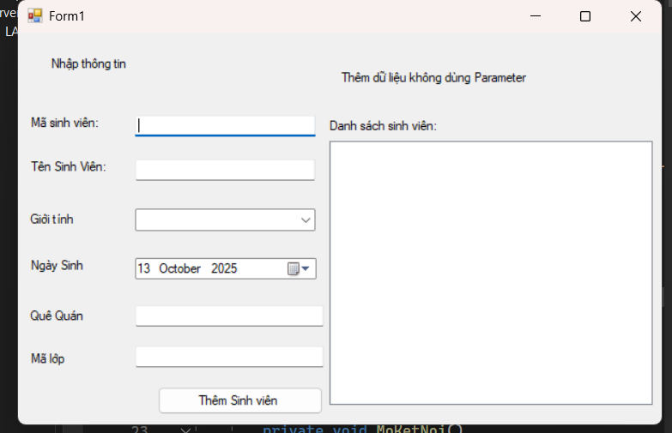

Thực hành 3: Sửa dữ liệu không dùng Parameter.

private void BtnSua_Click(object sender, EventArgs e)

{

try

{

if (string.IsNullOrWhiteSpace(txtMaSV.Text))

{

MessageBox.Show(" Vui lòng nhập Mã SV để sửa!", "Thông báo");

return;

}

MoKetNoi();

// Câu lệnh UPDATE dùng parameter để an toàn

string sql = @"UPDATE SinhVien

SET TenSV = @TenSV,

GioiTinh = @GioiTinh,

NgaySinh = @NgaySinh,

QueQuan = @QueQuan,

MaLop = @MaLop

WHERE MaSV = @MaSV";

using (SqlCommand cmd = new SqlCommand(sql, sqlCon))

{

cmd.Parameters.AddWithValue("@MaSV", txtMaSV.Text.Trim());

cmd.Parameters.AddWithValue("@TenSV", txtTenSV.Text.Trim());

cmd.Parameters.AddWithValue("@GioiTinh", cbGioiTinh.Text.Trim());

cmd.Parameters.AddWithValue("@NgaySinh", dtpNgaySinh.Value);

cmd.Parameters.AddWithValue("@QueQuan", txtQueQuan.Text.Trim());

cmd.Parameters.AddWithValue("@MaLop", txtMaLop.Text.Trim());

int kq = cmd.ExecuteNonQuery();

if (kq > 0)

{

MessageBox.Show("Sửa thông tin sinh viên thành công!", "Thành công");

HienThiDanhSach();

}

else

{

MessageBox.Show(" Không tìm thấy sinh viên có mã này!", "Thông báo");

}

}

}

catch (Exception ex)

{

MessageBox.Show(" Lỗi khi sửa dữ liệu: " + ex.Message);

}

finally

{

DongKetNoi();

}

}

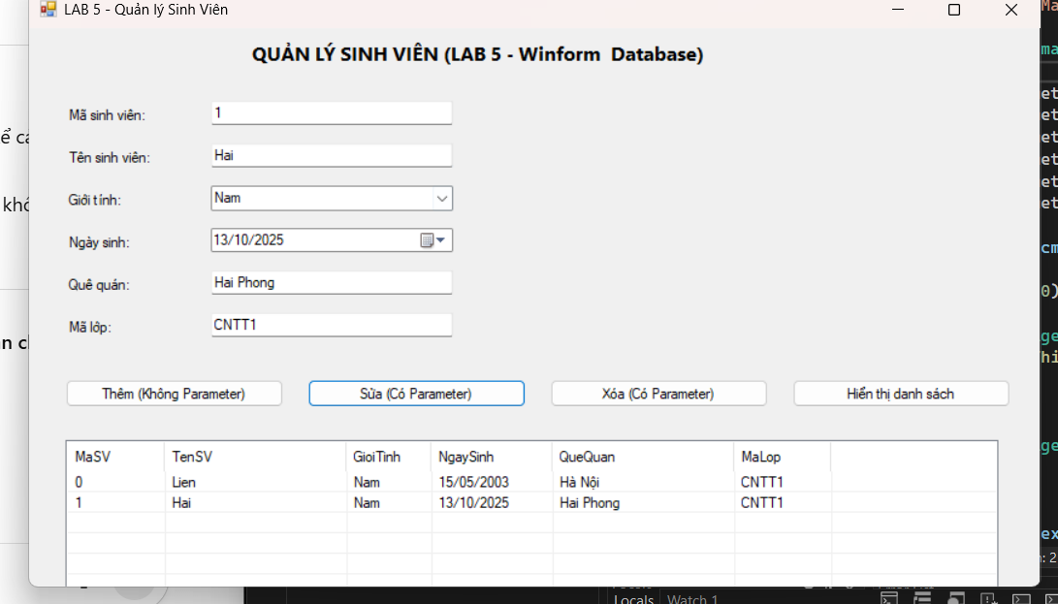

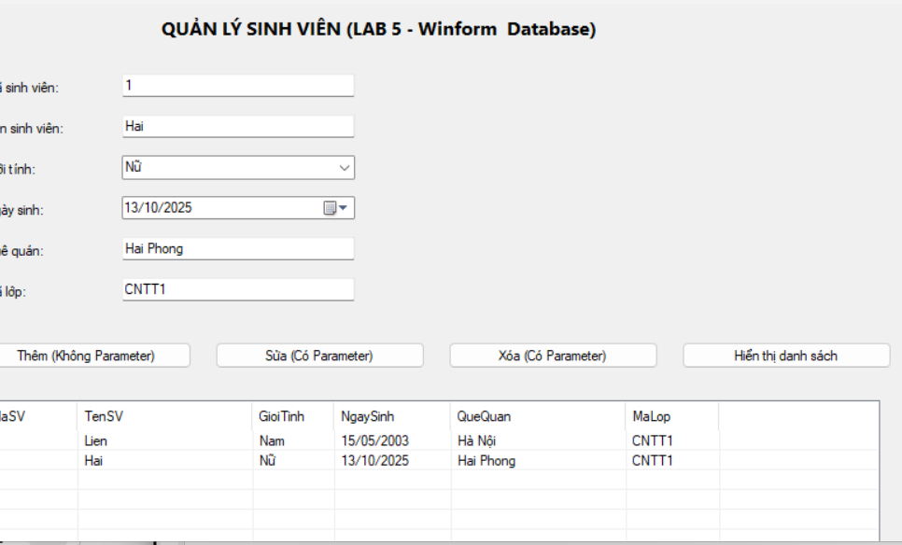

Thực hành 4: Xóa dữ liệu không dùng Parameter.

private void BtnXoa_Click(object sender, EventArgs e)

{

try

{

if (txtMaSV.Text == "")

{

MessageBox.Show(" Nhập Mã SV để xóa!");

return;

}

MoKetNoi();

SqlCommand cmd = new SqlCommand("DELETE FROM SinhVien WHERE MaSV=@MaSV", sqlCon);

cmd.Parameters.AddWithValue("@MaSV", txtMaSV.Text);

int kq = cmd.ExecuteNonQuery();

if (kq > 0)

{

MessageBox.Show(" Xóa thành công!");

HienThiDanhSach();

}

}

catch (Exception ex)

{

MessageBox.Show(" Lỗi khi xóa: " + ex.Message);

}

finally

{

DongKetNoi();

}

}

